**1.**Here is a sample html file with a button. Now modify the style of the paragraph text through javascript code.

Sample HTML file :

<!DOCTYPE html>

<html>  
<head>

<meta charset=utf-8 />

<title>JS DOM paragraph style</title>

</head>

<body>

<p id ='text'>JavaScript Exercises - </p>

<div>

<button id="jsstyle"

onclick="js_style()">Style</button>

</div>

</body>

</html>

Clicking on the button the font, font size, and color of the paragraph text will be changed.

**2.**Write a JavaScript function to get the values of First and Last name of the following form and combine them.

Sample HTML file :

<!DOCTYPE html>

<html><head>

<meta charset=utf-8 />

<title>Return first and last name from a form - </title>

</head><body>

<form id="form1" onsubmit="getFormvalue()">

First name: <input type="text" name="fname" value="David"><br>

Last name: <input type="text" name="lname" value="Beckham"><br>

<input type="BUTTON" value="Submit">

</form>

</body>

</html>

**3.**Write a JavaScript program to set the background color of a paragraph.

**4.**Write a JavaScript program to display all even numbers from 1 to 50 in a div

**5.**Write a JavaScript program to calculate the volume of a sphere.   
Sample Output of the form :

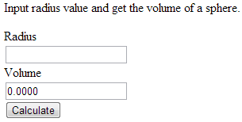

6. Write a Javascript program to calculate Simple Interest. Create a HTML form with needed elements.